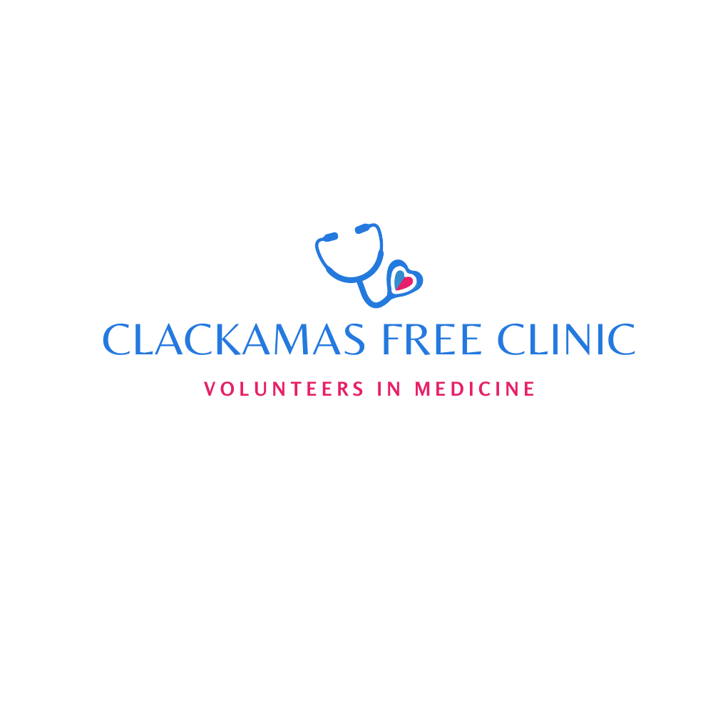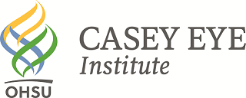

**WHAT:** Casey Community Outreach Program- Vision Screening Van

**WHEN:** **Saturday, April 13th, 2024** – 10 a.m. – 2:15 p.m.

*By appointment only- call 503-722-4400*

**WHERE:** Clackamas Free Clinic-Volunteers in Medicine

19600 Molalla Avenue Clairmont Hall Oregon City, OR. 97045

C:\Users\screener\AppData\Local\Microsoft\Windows\Temporary Internet Files\Content.IE5\5GIYZUJM\MC900334186[1].wmf**Details:** We will have free eye exams and glasses for low-income adults 18 years and older who are experiencing barriers to vision care. Waiting is to be expected so please bring a good book and a snack. There will be Spanish Interpreters available. Call (503) 722-4400 to get on the list.